【重点考点一】
用来询问钟表时间 的句型：问：What time is it?
答：It is + 钟表时间.例：--What time is it?--It is seven o'clock.
【拓展】
What time is it ?
= What’s the time ?
【重点考点二】It is time to /for... 表示......的时间到了1＞It is time to + 动原例：It is time to get up.
2＞It is time for + 名词例：It is time for school.
3＞It's time to + 动原=It's time for + 名词例：It is time to go to school.
=It is time for school.
【重点考点三】tired，形容词，疲倦的；累的短语：be tired例：I am tired.She is tired.
We are tired.
【拓展】be tired = feel tired例：
She is tired.= She feels tired.
【重点考点四】
时间表达法
1＞顺读法：
先读时，再读分
例：
5 ：40
↓ ↓
five forty

2 ：20
↓ ↓
two twenty

2＞逆读法
分在前，时在后；
过了用past, 未到用to
例1：
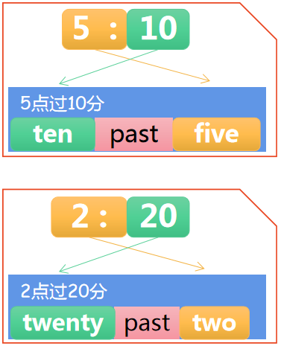

例2：(to后的小时数要加1)
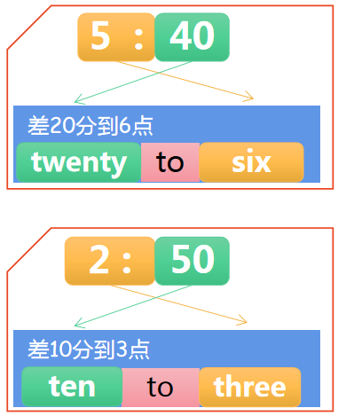
3＞其它时间
■ 1.整点：数字+o’clock
8：00
读作：eight o’clock

■ 2. 半点：half past + 时
9：30
读作：half past nine

■ 3. 一刻钟:
◆ a quarter past + 时
2：15
读作：a quarter past two

◆ a quarter to + （时+1）
3：45
读作：a quarter to four

【重点考点五】书本P19
动词+er ，变成(表示职业的)名词例：work +er = worker (工作→工人)farm +er = farmer(耕种→农民)teach +er = teacher(教导→教师)sing + er = singer(唱歌→歌手)

